**Cross-Platform Web Design – CST8117 – Section 011**

**Style Guide**

Contenido

Description 3

Fonts 4

Colors 5

Platform 6

Map 6

Pages 7

# Description

Our team's goal is to make a full shopping simulation of an online shoes shop, users will be able to browse items through properly organized layout and catalog, register and login their account, add items to cart and make the purchase. Data will be most likely stored in local JavaScript for single-use purposes considering our lack of knowledge on backend and cookies.



# Fonts

Font Family: **Open Sans**

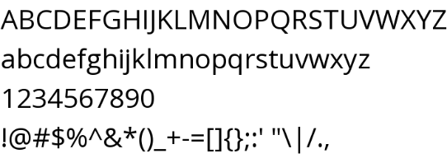

*H1 46px (Open Sans 700)*



*H2 32px (Open Sans 600)*



*H3 24px (Open Sans 400)*



*Body 16px (Open Sans 400)*



# Colors

**Main Color**

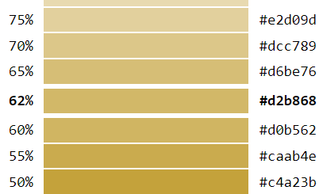

**Font Color:**



**Background Color:**



# Platform

The website will target traditional monitor resolutions of 1024X768 and greater and also surpporting screen size less than 500px width.

# Map

# Pages

**index.html**



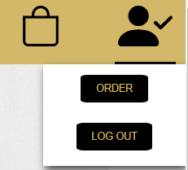

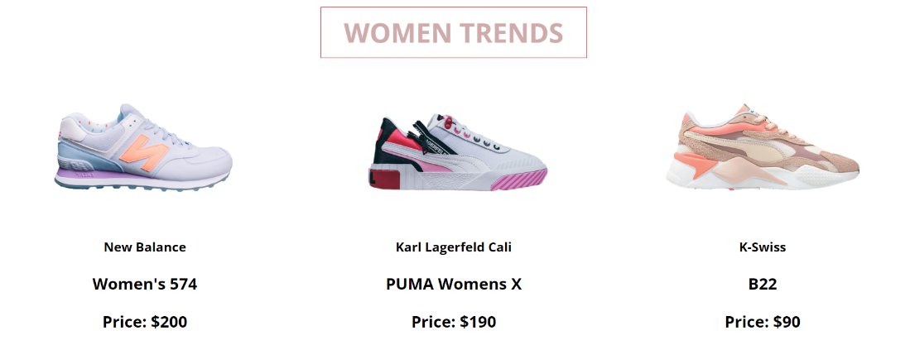

**Functions:**

* **loginCheck()**
* **cartCheck()**
* **getTrends()**

**List.html**

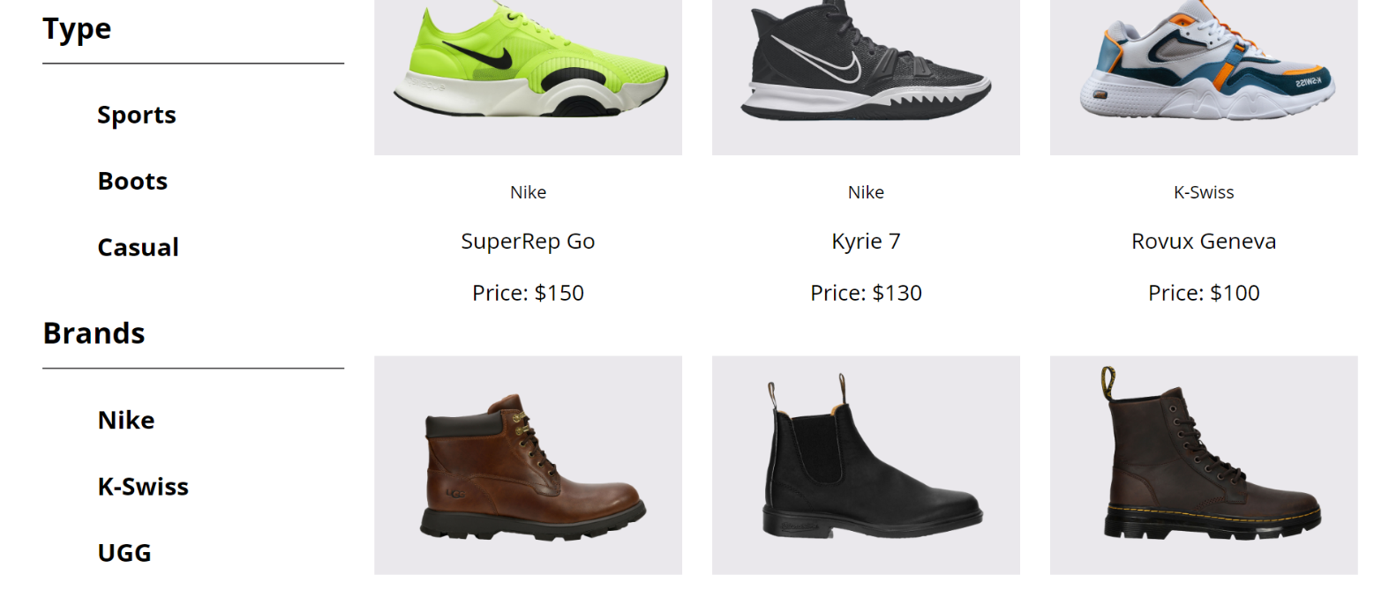

**Functions**:

* **loginCheck()**
* **cartCheck()**
* **filterByBrand ()**
* **filterByType ()**

**login.html**





**Functions**:

* **loginCheck()**
* **cartCheck()**
* **login()**
* **registración()**

**purchase.html**

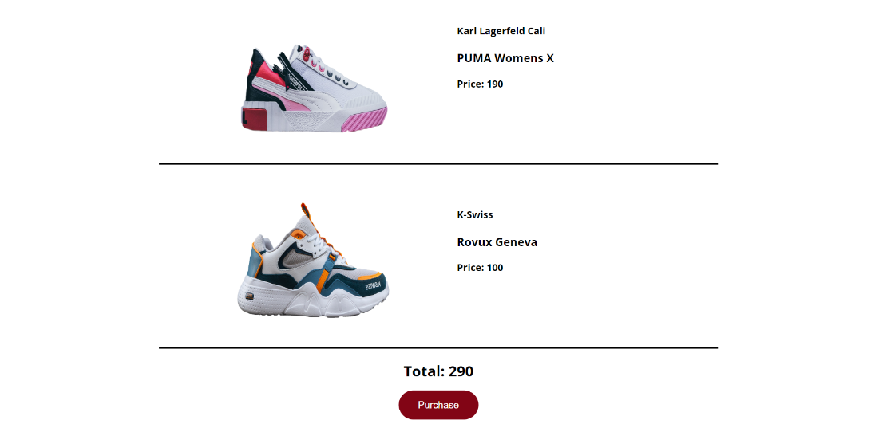

**Functions:**

* **purchase ()**
* **displayFinalCart()**

**Product.html**

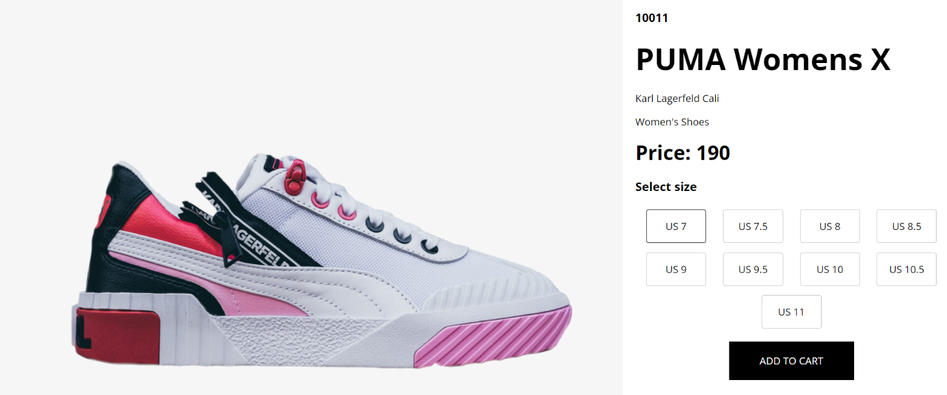 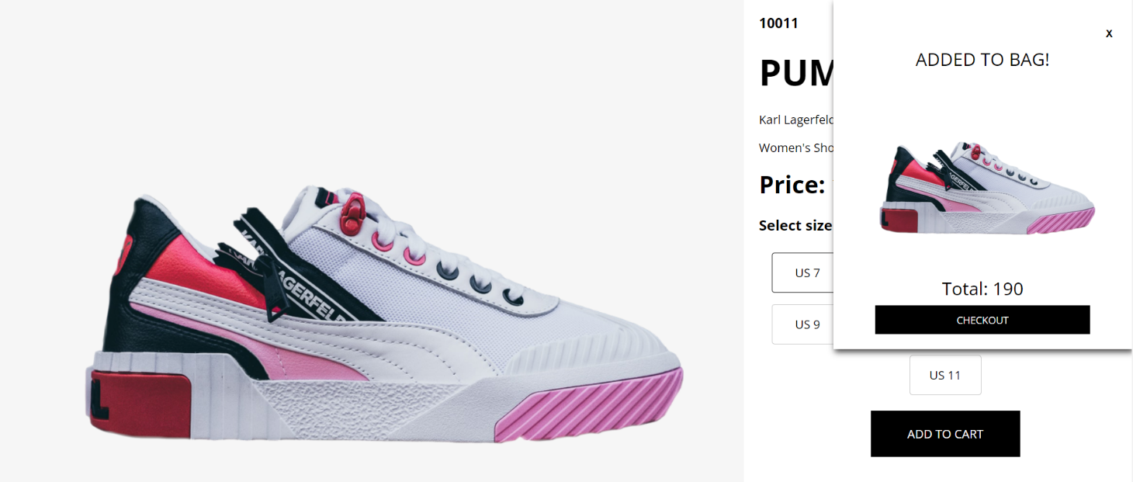

**Functions:**

* **loginCheck()**
* **cartCheck()**
* **displayCart()**
* **updateCart()**
* **closeCart()**
* **displayTotal()**
* **displayFinalCart()**